Capital City Wanderers is affiliated with the American Volkssport Association (AVA), an organization which consists of more than 300 clubs who develop walk routes across the USA. Besides holding special events in various locations, we have developed seven walks throughout Alabama which can be walked any day that the start point is open. They are called Year Round Events (YRE). To walk a YRE, go to the Start Point and retrieve the Walk Box. Follow the instructions in the box for registering. Take a set of walk directions and enjoy the scenery. There are also special events during the year. You do not have to be a member to participate. A fee of $3 is charged only to those who wish to stamp records books for IVV credit. All others walk free.
For additional information on Capital City Wanderers, Volkssporting or any of our events, visit our website at http://capitalcitywanderers.com or go to American Volkssport Association website, www.ava.org, where you can find events sponsored by other clubs in the USA.
Children under 12 must be accompanied by an adult. Please pick up your trash and pick up after your pet. Litter must be discarded in proper receptacles. No alcoholic beverages allowed along the routes.
Sylacauga, AL (Talledega County)
10K and 5K routes (rating 1A)
The course starts at Sylacauga’s City Hall next to Central Park at 301 N Broadway Ave, Sylacauga, AL 35150, across from the Blue Belle Ice Cream Factory. On weekdays from 9-5, enjoy two scoops of ice cream for only $1. During the walk, you will pass by the Corner Museum & Arts Center, the Sylacauga Marble Festival and the Church of the Highlands and First Church of the Nazarene. This walk is primarily on paved streets and sidewalks and with a short detour around Buddy Peter’s baseball field.
Date and time:
November 6, 2021
Start time: 9:00 a.m. until 12:00 p.m.
Finish time: 3:00 p.m.
Start Point / Driving Directions
301 N Broadway Ave, Sylacauga, AL 35150. From I65 S. use the left lane to take exit 261 B to merge onto I-20 E/I-59N N toward Atlanta/Gadsden. Take exit 126A to merge onto US-280 E/US 31S. Use the right 2 lanes to take the exit toward Sylacauga E. Follow US- 280 E to W 3rd St in Sylacauga. From I 65 N. to Co Rd 59/Co Rd 706 in Chilton County, follow AL-22 E to US-231 N/Main St. in Rockford, turn left onto US-231 N/Main St and then follow S Broadway Ave to W 3rd St.
Special Programs: No special programs available.
Medium suitability for wheelchairs and strollers. Restrooms are available along the route.

Lineville, AL (Clay County)
10K and 5K routes (rating 2A)
The course starts at the Piggly Wiggly parking lot behind the brick bank building at the corner of 5th Ave and Main Street (Hwy 9), Lineville, AL. During the walk you will walk around the town and residential areas of Lineville, which is a typical small Alabama town. The city park has a Veteran’s Memorial, This walk is primarily on paved streets and sidewalks. There are areas where there are no sidewalks so walkers need to be alert and use caution.

Date and time:
November 7, 2021
Start time: 9:00 a.m. until 12:00 p.m.
Finish time: 3:00 p.m.

Directions to Start Point:
From I-20, take exit number 191, onto US-431 S. Turn right onto AL-9 S. Proceed until you reach Lineville. Turn right at 5th Ave. and then turn left into the parking lot. Park behind the brick bank building on the corner of 5th Ave and Main Street (Hwy 9).
Special Programs: Walk with America’s Veterans
Not suitable for wheelchairs but medium suitability for strollers. Restrooms are available at Jack’s Restaurant and at several service stations/convenience stores near the start point.

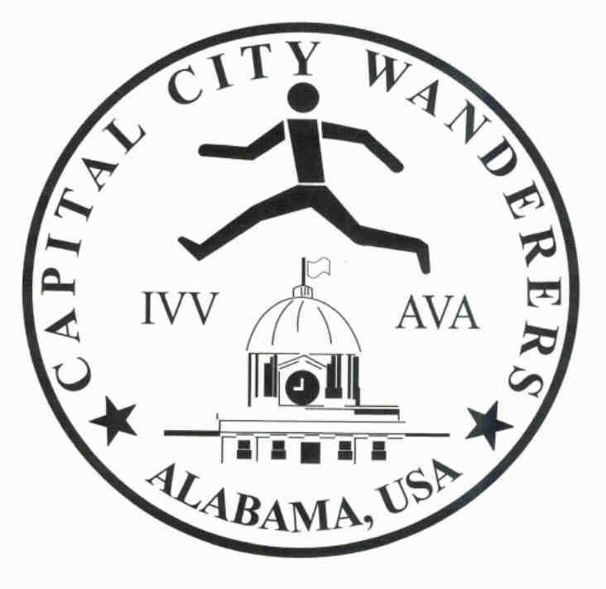

SYLACAUGA, AL
(TALLEDEGA COUNTY)
And
LINEVILLE, AL
(CLAY COUNTY) VOLKSMARCHES
November 6 and 7, 2021
Sponsored by Capital City Wanderers Walking Club, Inc.

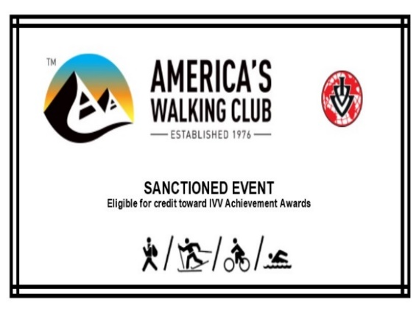

http://capitalcitywanderers.com

